**Module 4 Pandas Challenge**

**Jaspreet Kalsi**

**Analysis**

**District summary**

From the data provided, we can gather that there are a total of 39,170 students across 15 schools. The total budget of all these schools is $24,649,428. This is summarised in *Table 1.*

The average math grade is 74.98%, and the average reading grade is 85.81%. The overall passing rate for maths and reading is 65.17%.



*Table 1: District summary*

**School summary**

*Table 2: School summary*

The table above outlines the results from the data set provided.

**Results**

The highest performing school in the district is Cabrera High School with the highest overall passing grade for maths and reading as shown in *Table 3.*

*Table 3: Highest performing schools (by % overall passing)*

Alternatively, the lowest performing school is shown to be Rodriguez High School, as implied in *Table 4,* with an overall passing rate of 52%

*Table 4: Bottom performing schools (by % overall passing)*

Looking through the results of math and reading scores by grade as shown in *tables 5 and 6* respectively, it can be noted that there is little variation of results between the four grades analysed. The results remain consistent as the grade progresses.

*Table 5: Math score by grade Table 6: Reading score by grade*

The results in table 7 show that schools with a lower spending range resulted in better academic outcomes. For example, the overall outcome passing rate for spending ranges per student in the <$585 bracket was higher than the figures in the $645-680 bracket by approximately 36.81%.

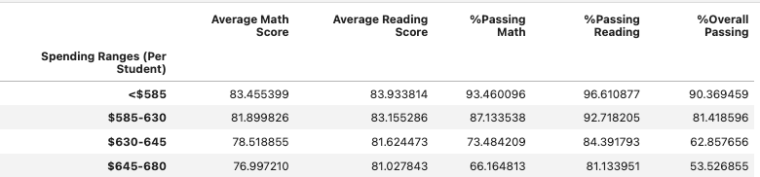

*Table 7: Scores by school spending*

Schools that had a smaller and medium student body count were considerably more academically successful compared to the larger school. *Table 8* shows that medium schools which have a population of 1000 to 2000 had the highest overall passing rate with 90.62%, whereas the larger school with a population of over 2000 students dropped down to 58.29%.

*Table 8: Scores by school size*

The data provided shows that the 15 schools are divided into two types: charter and district. Table 9 illustrates that charter schools score higher than district schools by a substantial amount.

*Table 9: Scores by school type*